11th May 2018

Yvan Muller wins race 1 at WTCR Race of Germany

The new series which has the Japanese Tyre manufacturer YOKOHAMA as official tyre supplier, is becoming increasingly popular among fans as indeed among the drivers who are all taking their chances and picking up valuable points. With three FIA WTCC Champions filling the Nordschleife podium after an epic race 1, Yvan Muller was all smiles ahead of Björk and Huff.

Touring car legend Yvan Muller beat YMR team-mate Thed Björk off the line in Race 1 at WTCR Race of Germany and held on to win as three world champions stood together on the WTCR – FIA World Touring Car Cup after a thrilling show of close racing at the Nürburgring Nordschleife on Thursday evening.

Björk started from Pole Position, but Muller was faster off the line to take the lead into Turn 1. Björk chased his team boss all the way over three scintillating laps of the 25.378-kilometre circuit, but couldn’t find a way past the identical Hyundai i30 N TCR.
“A perfect day,” said four-time World Touring Car champion Muller after congratulating his team-mate. “I didn’t expect to be that fast. I gave everything I had – even more. “I had a great start, but then had to manage my lead. It was tough, but I’m so happy and we have a team 1-2 as well.”

Sébastien Loeb Racing’s Rob Huff and BRC Racing Team’s Norbert Michelisz chased the all-white Hyundai pair all the way in a four-car train. Huff, starting fifth, made a strong start and passed Michelisz for third as they headed on to the Nordschleife for the first time.
The Hungarian tried everything to demote the Briton and was alongside for the final run up the long Döttinger Höhe straight, but Volkswagen Golf GTI TCR driver Huff held his nerve to ensure that three FIA world champions would stand together on the podium.

A little further back, Jean-Karl Vernay was fifth having started ninth in his Audi Sport Leopard Lukoil Team Audi RS 3 LMS, ahead of wildcard entry and team-mate for the weekend René Rast. The German DTM champion had lined up P15 after a 10-place grid penalty, incurred for not slowing sufficiently for yellow flags in qualifying.

There was disappointment for championship leader Gabriele Tarquini, who still heads the points despite crashing out. The Italian was running sixth when he ran into the barrier at the final chicane at the end of the first lap.

Action resumes at WTCR Race of Germany on Friday, with the second qualifying session taking place at 17h35 local time. Races 2 and 3 follow on Saturday.

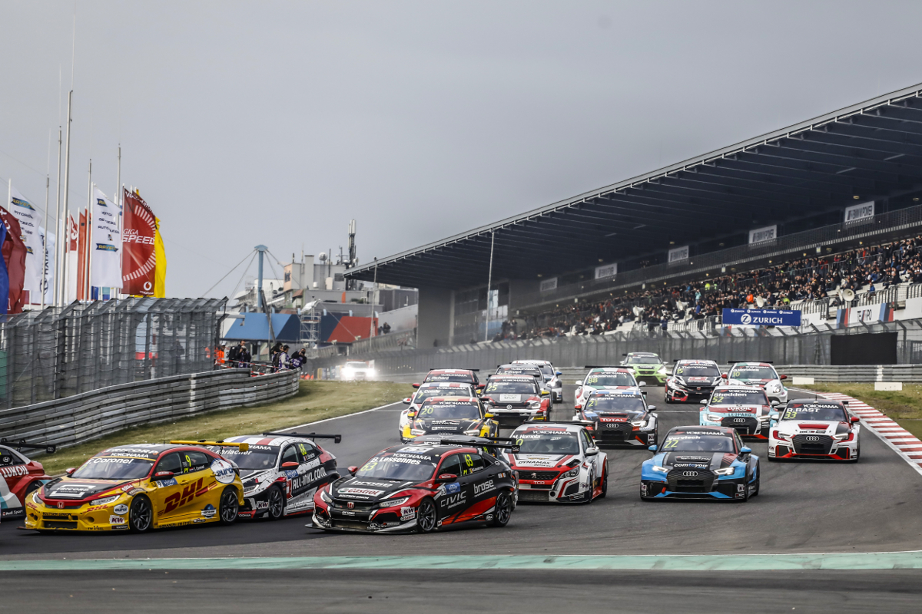
Off they go at the Green Hell with the WTCR - Photo Francois Flamand

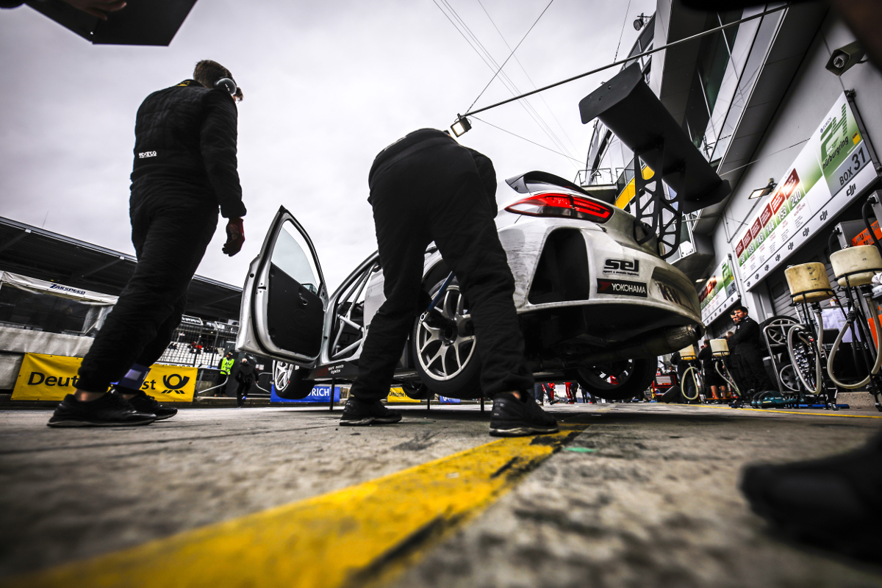
Yvan Muller 's Hyundai i30 N TCR getting the winning tyres on - Photo by Francois Flamand

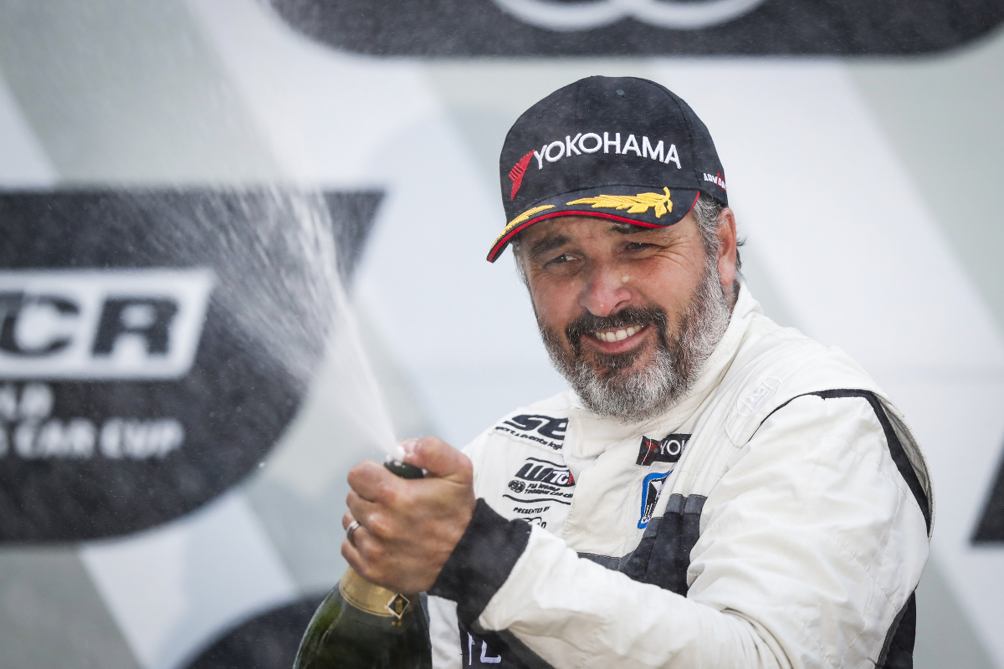
Yvan Muller tops the podium in Race 1 - Photo by Florent Gooden

